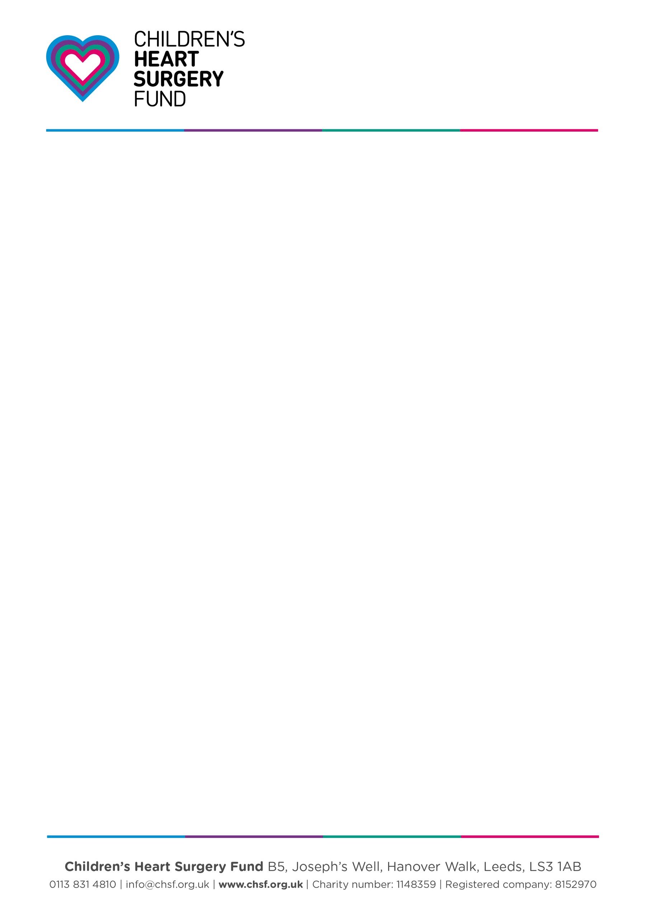


[Your Name]
[Your Address]
[Your Address cont.]
[Phone / Email]
[Business Name]
[Business Address]
[Business Address cont.]
Support Children’s Heart Surgery Fund any day in February 2026 by taking part in Wear Red Day.
Dear [Business/Contact Name],
I wanted to write and let you know about how your company can get involved and support Wear Red Day this year for Children’s Heart Surgery Fund.
Congenital heart disease (CHD) is the most common birth defect with 13 babies being diagnosed with a congenital heart defect every day in UK. The range of conditions and treatments available mean that for children and parents the treatment pathway can be very different to anyone else they might meet with CHD.
Children’s Heart Surgery Fund receives no government or NHS funding and relies solely on public support. Any help you can give would be amazing.
I do hope you’ll be able to join in and be part of this great fundraising campaign. There are lots of ways you can get involved. From the simple action of your staff wearing red (maybe your colleague has a burning wish to be Po from the Teletubbies for the day?) to a red chilli eating competition or red bake sale. Whatever you decide to do for Wear Red Day 2026, every penny raised will go to support the thousands of babies, children and adults living with heart disease in our region.
I really hope you will consider our request for support and look forward to hearing from you. You can find out more about the event at chsf.org.uk/wear-red-day.
Yours sincerely,

[YOUR NAME]

